1. Introduction

This document aims to evaluate the effective effort needed to entirely develop MyTaxi project

in all its features, and after that give a hypothesis on how to schedule the development. The

evaluation starts with a Function Point Analysis, which will provide a rough estimate of the

SLOC (Source Lines of Code). Then with SLOC value, we will proceed with a COCOMO II analysis

to calculate correspondent Effort and Duration.

The second part of the document will explain the project schedule through tasks identification

and allocation to team members.

2. Project Size and Cost evaluation

2.1. Function Point Analysis

http://csse.usc.edu/csse/research/COCOMOII/cocomo2000.0/CII_modelman2000.0.pdf

The first Table is used to evaluate the complexity:

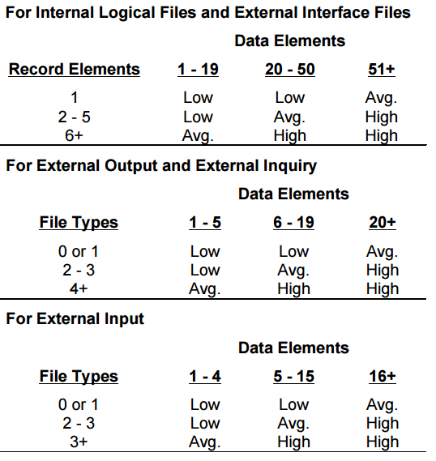

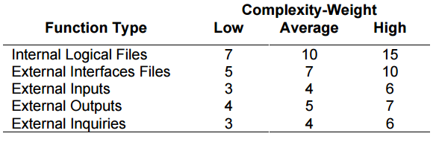

For this evaluation, we will use Java Enterprise Edition, which has a converting factor of 46 SLOC/FP.

<http://www.qsm.com/resources/function-point-languages-table>

2.1.1. Internal Logic Files

|  |  |  |
| --- | --- | --- |
| Internal Logic Files | Complexity | Function Points |
| User | High | 15 |
| Ride | High | 15 |
| Reservation | High | 15 |
| Safe Area | Low | 7 |
| Special Safe Area | Average | 10 |
| Payment Method | Low | 7 |
| Car | Average | 10 |
| Emplyee | Average | 10 |
| Total | | 89 |

2.1.2. External Interface Files

|  |  |  |
| --- | --- | --- |
| External Interace Files | Complexity | Function Points |
| Mail Server | Low | 5 |
| Sms Server | Low | 5 |
| Payment System | Average | 7 |
| Total | | 17 |

2.1.3. External Inputs

|  |  |  |
| --- | --- | --- |
| External Inputs | Complexity | Function Points |
| Login/Logout/Register | Low | 3x3 |
| Car Reservation | Average | 4 |
| Unlock / Lock car | Average | 4 |
| Calculate route | Average | 4 |
| Update user’s information | Low | 3 |
| Update car status | Low | 3 |
| Begin/Close the ride | Average | 4 |
| Send ride information from car to the system | Low | 3 |
| Total | | 34 |

2.1.4. External Inquiries